UNDERSTANDING DOCUMENT TO SWAP PARTNER IN ODOO

STEP 1 :

* Send swap/migrate partner request to accounts team via email

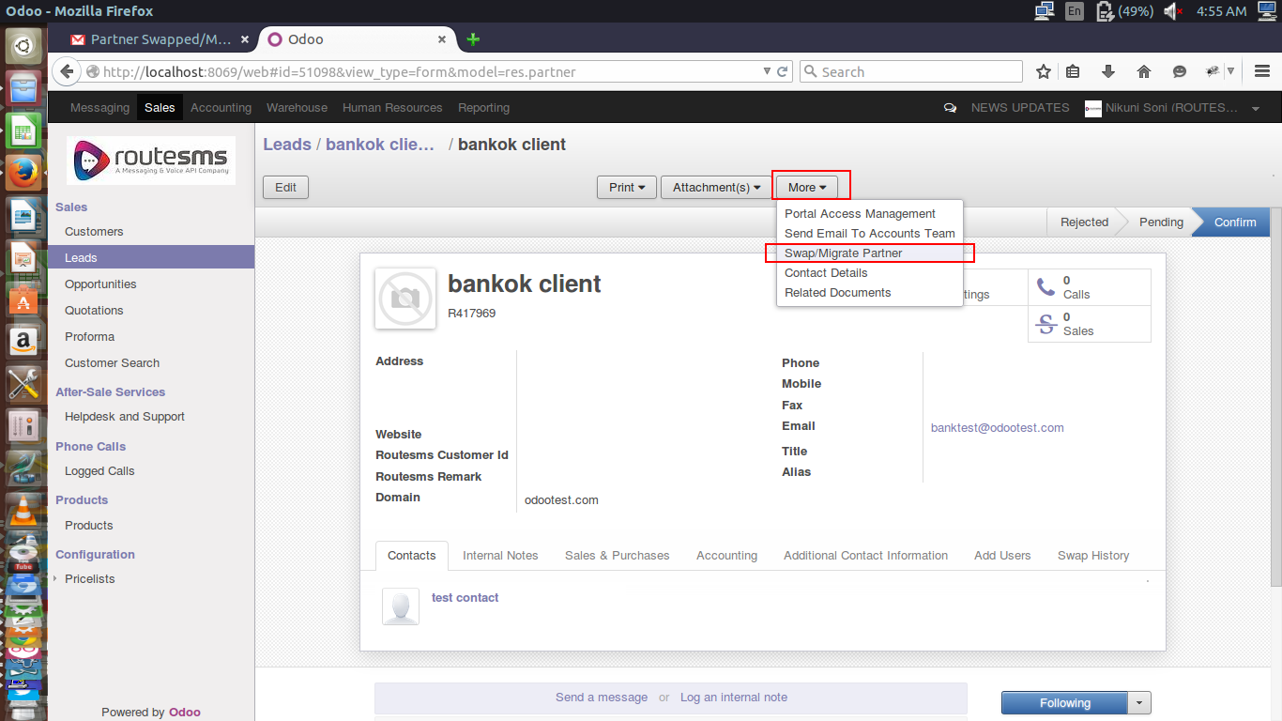

STEP 2:

* Select Salesuser name to swap/migrate.

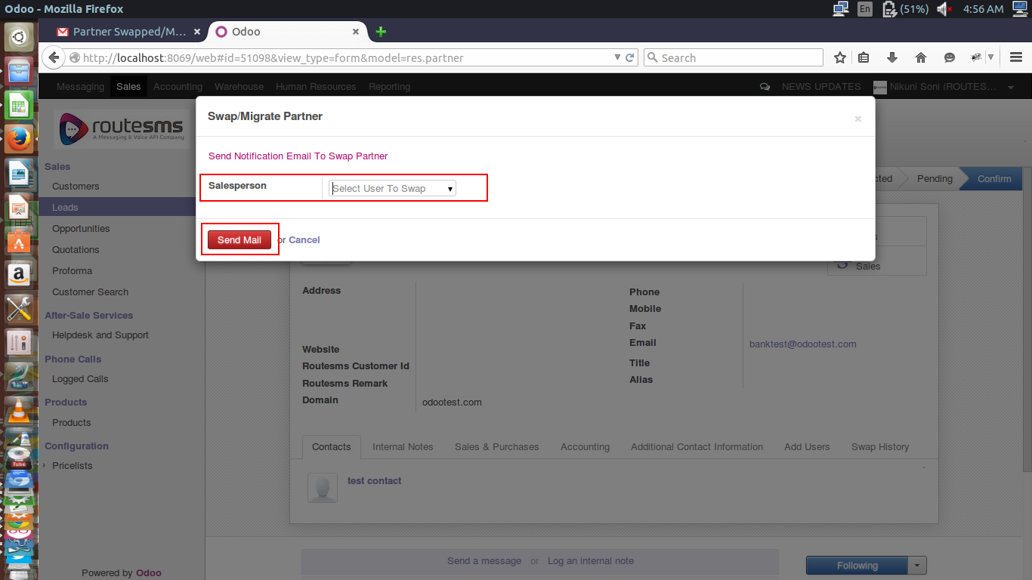

STEP 3:

* Partner and its associated documents like leads,proforma,invoices,payments will be swapped /migrated to selected salesperson from list.

*Click on “Send Mail” button to send email notification to accounts team.

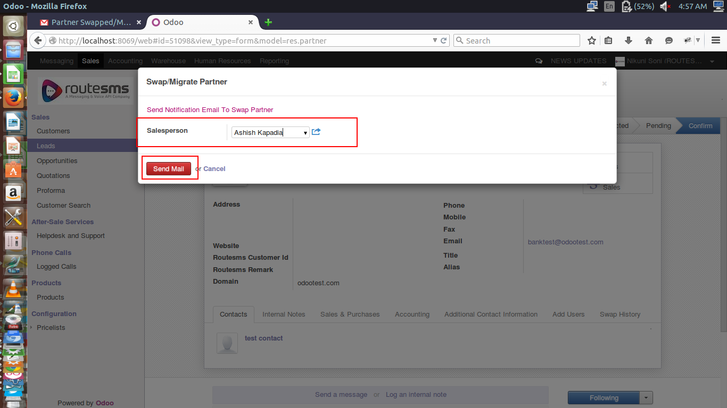

STEP 4: (FOR ACCOUNT USERS ONLY)

* Accounts team will receive request notification via email.

* Change the salesperson as per request and click on “Save” button

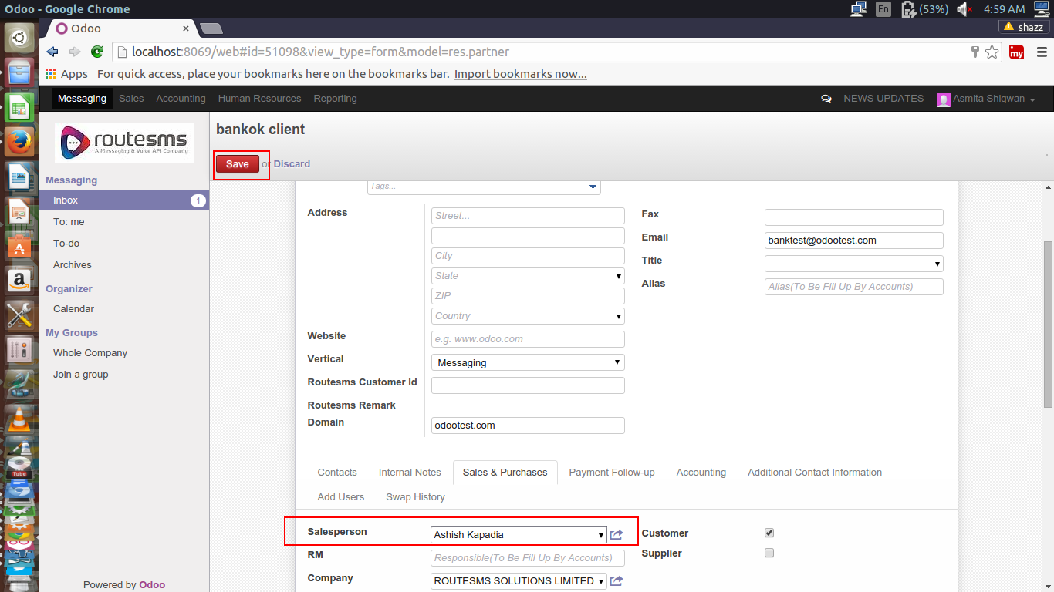

STEP 5:

* After successful swapping /migration of partner along with associated documents, salesperson can view history of swapped client.

* Swapped history shows the partner migration logs from one salesperson to another.

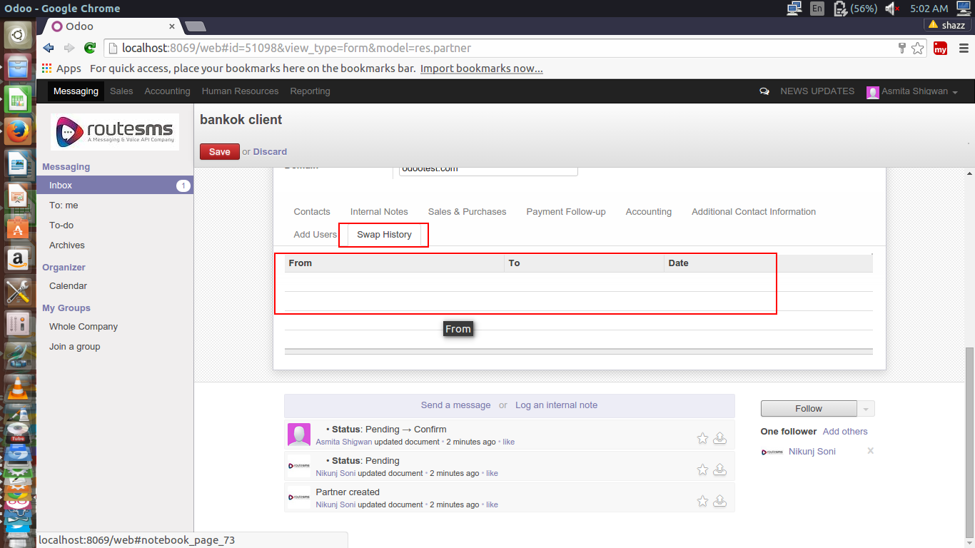

THANK YOU

